Develop and compare CLI, GUI, and Voice User
Interfaces (VUI) for the same task and assess user
satisfaction using Python (Tkinter for GUI, Speech
Recognition for VUI)terminal
Python code for CLI:
import sys
correct_pin = "1234"
balance = 10000
transaction_history = []

def check_balance():
print(f"\n💰 Available Balance: ₹{balance}")
transaction_history.append("Checked Balance")

def deposit():
global balance
try:
amount = float(input("Enter amount to deposit: ₹"))
if amount > 0:
balance += amount
transaction_history.append(f"Deposited ₹{amount}")
print("✅ Deposit successful!")
else:
print("❌ Enter valid amount.")
except ValueError:
print("❌ Invalid input.")

def withdraw():
global balance
try:
amount = float(input("Enter amount to withdraw: ₹"))
if amount <= 0:
print("❌ Enter valid amount.")
elif amount > balance:
print("❌ Insufficient balance.")
else:
balance -= amount
transaction_history.append(f"Withdrew ₹{amount}")
print("✅ Withdrawal successful!")
except ValueError:
print("❌ Invalid input.")

def show_history():
print("\n📜 Transaction History:")
if transaction_history:
for t in transaction_history:
print("-", t)
else:
print("No transactions yet.")

def atm():
attempts = 3

while attempts > 0:
pin = input("Enter your 4-digit PIN: ")

if pin == correct_pin:
print("\n✅ Login Successful!")
break
else:
attempts -= 1
print(f"❌ Incorrect PIN. Attempts left: {attempts}")

if attempts == 0:
print("🚫 Card blocked. Too many wrong attempts.")
sys.exit()

while True:
print("\n===== SMART ATM MENU =====")
print("1. Check Balance")
print("2. Deposit Money")
print("3. Withdraw Money")
print("4. Transaction History")
print("5. Exit")

choice = input("Select option: ")

if choice == '1':
check_balance()
elif choice == '2':
deposit()
elif choice == '3':
withdraw()
elif choice == '4':
show_history()
elif choice == '5':
print("👋 Thank you for using Smart ATM!")
break
else:
print("❌ Invalid option.")

if __name__ == "__main__":
atm()
OUTPUT:
Enter your 4-digit PIN: 0702
❌ Incorrect PIN. Attempts left: 2
Enter your 4-digit PIN: 1234

✅ Login Successful!

===== SMART ATM MENU =====
1. Check Balance
2. Deposit Money
3. Withdraw Money
4. Transaction History
5. Exit
Select option: 3
Enter amount to withdraw: ₹1000
✅ Withdrawal successful!

===== SMART ATM MENU =====
1. Check Balance
2. Deposit Money
3. Withdraw Money
4. Transaction History
5. Exit
Select option: 1

💰 Available Balance: ₹9000.0

===== SMART ATM MENU =====
1. Check Balance
2. Deposit Money
3. Withdraw Money
4. Transaction History
5. Exit
Select option: 2
Enter amount to deposit: ₹1000
✅ Deposit successful!

===== SMART ATM MENU =====
1. Check Balance
2. Deposit Money
3. Withdraw Money
4. Transaction History
5. Exit
Select option: 1

💰 Available Balance: ₹10000.0

===== SMART ATM MENU =====
1. Check Balance
2. Deposit Money
3. Withdraw Money
4. Transaction History
5. Exit
Select option: 4

📜 Transaction History:
- Withdrew ₹1000.0
- Checked Balance
- Deposited ₹1000.0
- Checked Balance

===== SMART ATM MENU =====
1. Check Balance
2. Deposit Money
3. Withdraw Money
4. Transaction History
5. Exit
Select option: 5
👋 Thank you for using Smart ATM!

PYTHON CODE FOR GUI:
import tkinter as tk
from tkinter import messagebox

correct_pin = "1234"
balance = 10000
transaction_history = []
attempts = 3

def check_balance():
messagebox.showinfo("Balance", f"Available Balance: ₹{balance}")
transaction_history.append("Checked Balance")

def deposit():
global balance
try:
amount = float(amount_entry.get())
if amount > 0:
balance += amount
transaction_history.append(f"Deposited ₹{amount}")
messagebox.showinfo("Success", "Deposit Successful!")
amount_entry.delete(0, tk.END)

else:
messagebox.showerror("Error", "Enter valid amount")
except ValueError:
messagebox.showerror("Error", "Invalid input")

def withdraw():
global balance
try:
amount = float(amount_entry.get())
if amount > balance:
messagebox.showerror("Error", "Insufficient Balance")
elif amount <= 0:
messagebox.showerror("Error", "Enter valid amount")
else:
balance -= amount
transaction_history.append(f"Withdrew ₹{amount}")
messagebox.showinfo("Success", "Withdrawal Successful!")
amount_entry.delete(0, tk.END)
except ValueError:
messagebox.showerror("Error", "Invalid input")

def show_history():
if transaction_history:
history_text = "\n".join(transaction_history)
else:
history_text = "No transactions yet."
messagebox.showinfo("Transaction History", history_text)

def login():
global attempts
pin = pin_entry.get()

if pin == correct_pin:
login_frame.pack_forget()
menu_frame.pack()
else:
attempts -= 1
messagebox.showerror("Error", f"Incorrect PIN. Attempts left: {attempts}")
if attempts == 0:
messagebox.showerror("Blocked", "Card Blocked!")
root.destroy()
root = tk.Tk()
root.title("Smart ATM Simulator")
root.geometry("350x450")
root.resizable(False, False)
login_frame = tk.Frame(root)
login_frame.pack(pady=50)

tk.Label(login_frame, text="Enter 4-Digit PIN", font=("Arial", 14)).pack(pady=10)
pin_entry = tk.Entry(login_frame, show="*", width=20)
pin_entry.pack(pady=10)
tk.Button(login_frame, text="Login", width=15, command=login).pack(pady=10)
menu_frame = tk.Frame(root)

tk.Label(menu_frame, text="SMART ATM MENU", font=("Arial", 14)).pack(pady=10)
tk.Button(menu_frame, text="Check Balance", width=20, command=check_balance).pack(pady=5)
tk.Label(menu_frame, text="Enter Amount").pack(pady=5)
amount_entry = tk.Entry(menu_frame, width=20)
amount_entry.pack(pady=5)
tk.Button(menu_frame, text="Deposit", width=20, command=deposit).pack(pady=5)
tk.Button(menu_frame, text="Withdraw", width=20, command=withdraw).pack(pady=5)
tk.Button(menu_frame, text="Transaction History", width=20, command=show_history).pack(pady=5)
tk.Button(menu_frame, text="Exit", width=20, command=root.quit).pack(pady=10)

root.mainloop()
OUTPUT:
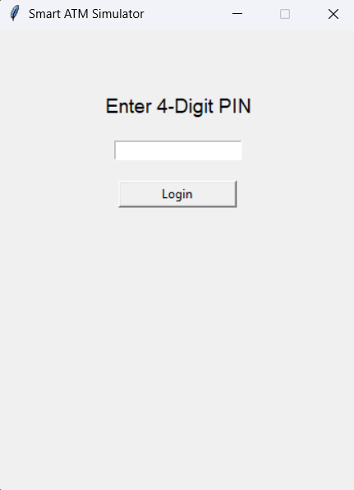
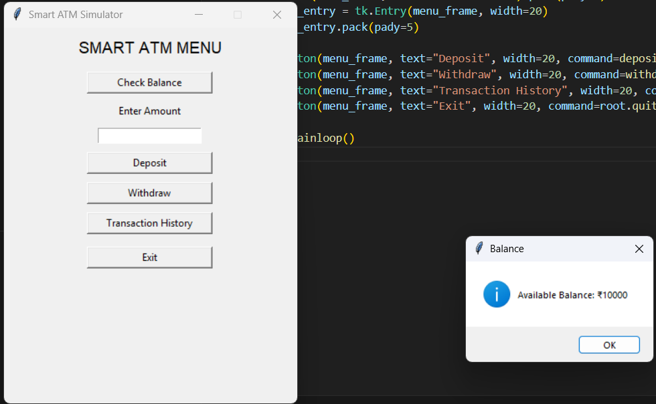

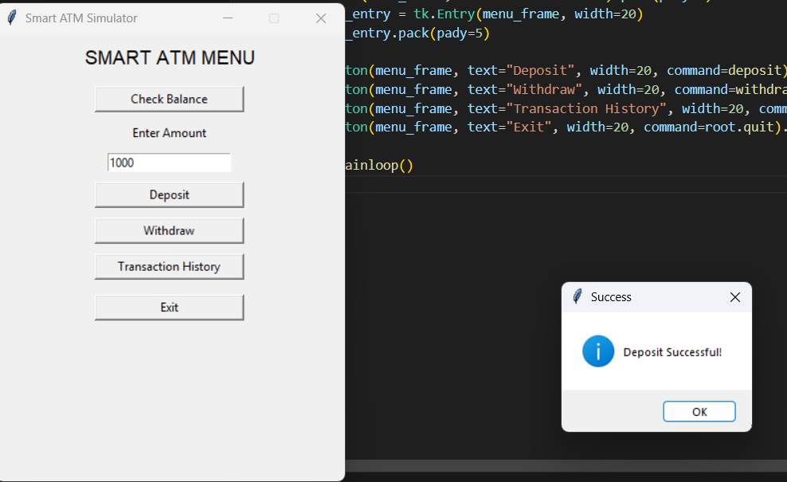

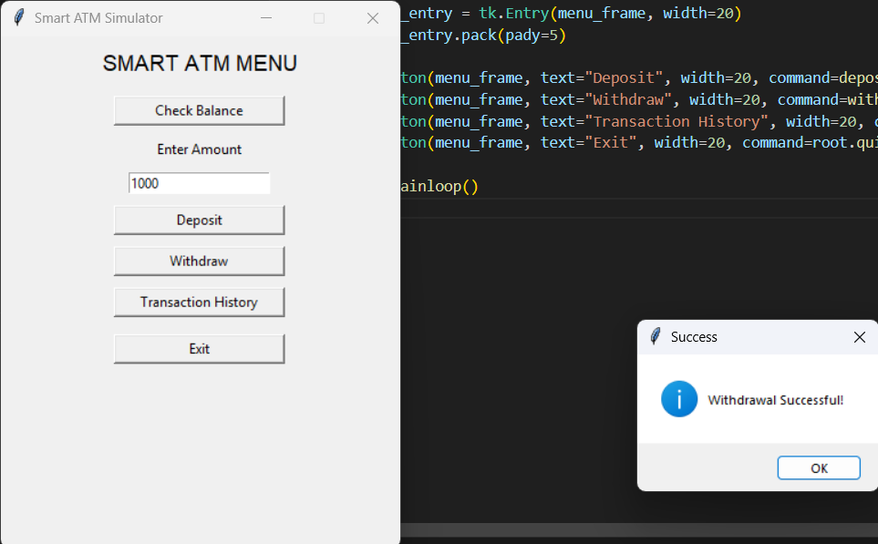

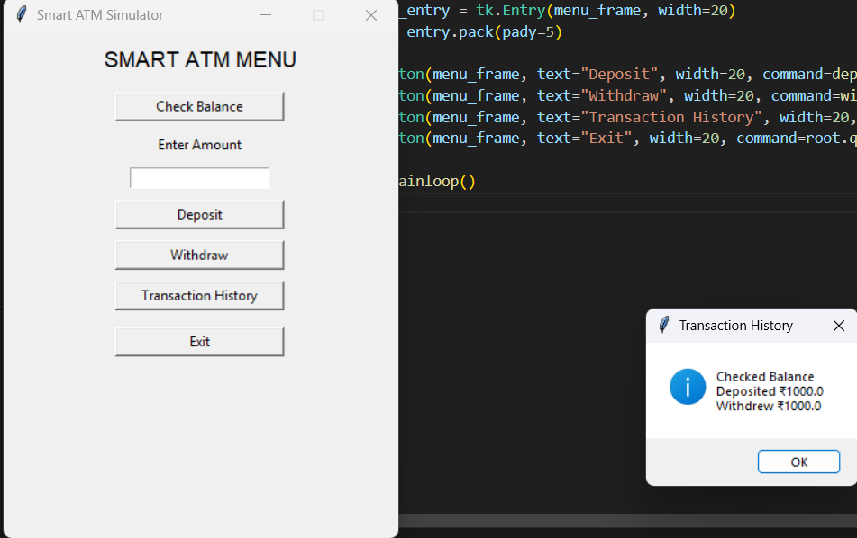

PYTHON CODE FOR VUI:
import speech_recognition as sr
import pyttsx3
import sys

correct_pin = "1234"
balance = 10000
transaction_history = []

engine = pyttsx3.init()
recognizer = sr.Recognizer()

def speak(text):
print("ATM:", text)
engine.say(text)
engine.runAndWait()

def listen():
with sr.Microphone() as source:
print("Listening...")
audio = recognizer.listen(source)
try:
command = recognizer.recognize_google(audio)
print("You said:", command)
return command.lower()
except:
speak("Sorry, I did not understand.")
return ""

def check_balance():
speak(f"Your available balance is {balance} rupees")
transaction_history.append("Checked Balance")

def deposit():
global balance
speak("Please say the deposit amount")
amount_text = listen()

try:
amount = float(amount_text)
if amount > 0:
balance += amount
transaction_history.append(f"Deposited ₹{amount}")
speak("Deposit successful")
else:
speak("Invalid amount")
except:
speak("Could not understand the amount")

def withdraw():
global balance
speak("Please say the withdrawal amount")
amount_text = listen()

try:
amount = float(amount_text)
if amount > balance:
speak("Insufficient balance")
elif amount <= 0:
speak("Invalid amount")
else:
balance -= amount
transaction_history.append(f"Withdrew ₹{amount}")
speak("Withdrawal successful")
except:
speak("Could not understand the amount")

def show_history():
if transaction_history:
speak("Your transaction history is")
for t in transaction_history:
speak(t)
else:
speak("No transactions yet")

def atm():
attempts = 3
speak("Welcome to Smart ATM")
speak("Please say your 4 digit pin")

while attempts > 0:
pin = listen()

if pin == correct_pin:
speak("Login successful")
break
else:
attempts -= 1
speak(f"Incorrect pin. {attempts} attempts left")

if attempts == 0:
speak("Card blocked due to wrong pin")
sys.exit()

speak("You can say check balance, deposit, withdraw, history, or exit")

while True:
command = listen()

if "balance" in command:
check_balance()
elif "deposit" in command:
deposit()
elif "withdraw" in command:
withdraw()
elif "history" in command:
show_history()
elif "exit" in command:
speak("Thank you for using Smart ATM")
break
else:
speak("Invalid command")

if __name__ == "__main__":
atm()

OUTPUT:
ATM: Welcome to Smart ATM
ATM: Please say your 4 digit pin
Listening...
You said: 1234
ATM: Login successful
ATM: You can say check balance, deposit, withdraw, history, or exit
Listening...
You said: check balance
ATM: Your available balance is 10000 rupees
Listening...
You said: history
ATM: Your transaction history is
ATM: Checked Balance
Listening...
You said: exit
ATM: Thank you for using Smart ATM

